**Intro**

Create a page that is using the jQuery library

Print ‘Hello, world!’ in console when DOM loads

**Selecting**

Create a page that contains navigation (ul element)  
Navigation should contain odd number of elements

Select the first element of the list and give it a bottom border

Select all list elements and transform their text to uppercase

Select active element of the list and change its font color

Find the middle one and change its background color

**Inserting elements**

Start with a blank HTML page

Using just JS (jQuery), create an image gallery

***All links to images in the gallery should be elements of the same array!***

When the gallery is created and visible on the page, create gallery title and insert it before the gallery images

Go through gallery images and set a random size to each gallery image

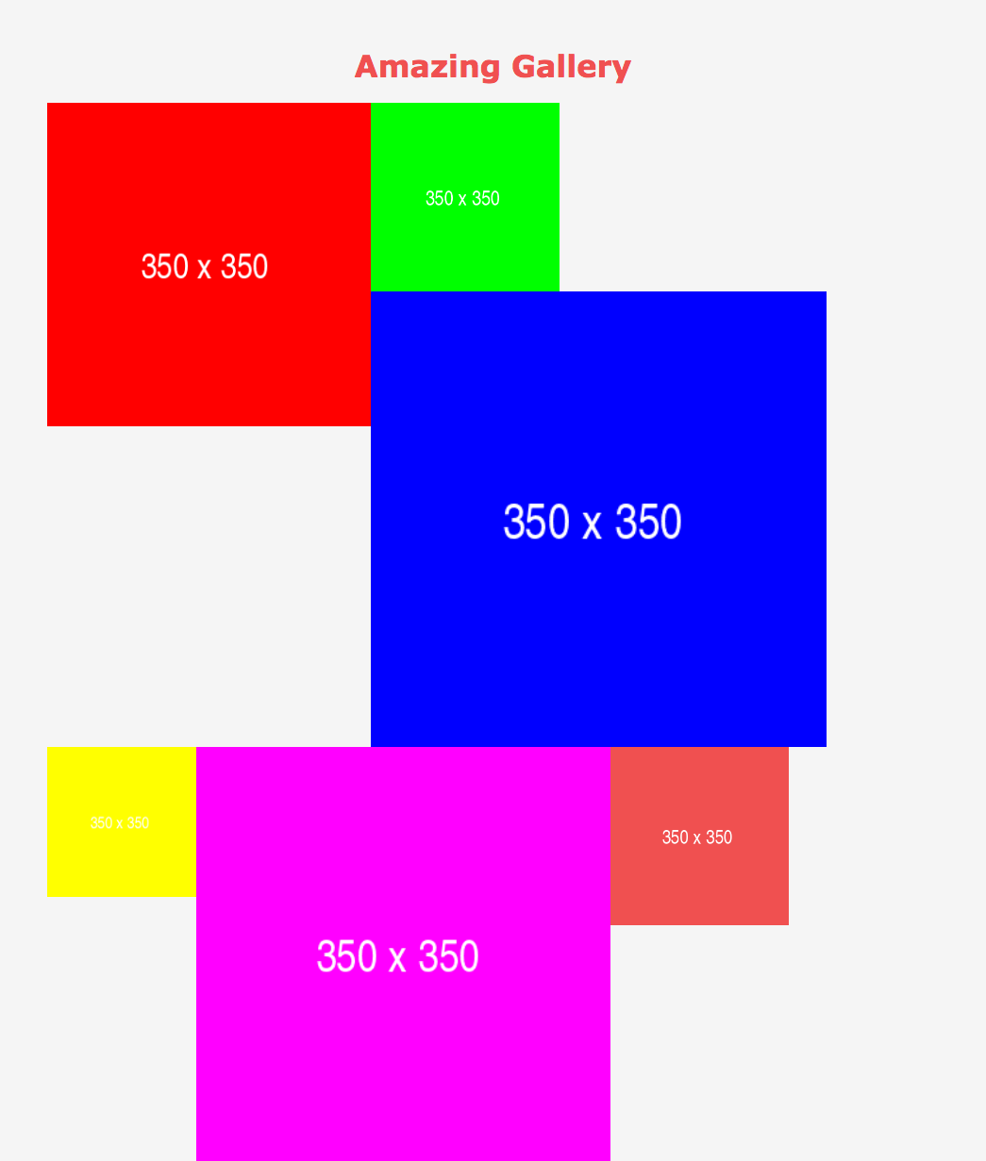

Bonus:

Set a green border around each image whose width is less than 200px up until the first one that doesn't meet that requirement (i.e. when you get to the first img that is more than 200px wide, stop checking and setting green border).

**Event Handling**

Redo football example using jQuery

**Traverse (Redo Gallery)**

Create a page with two “galleries”

Each gallery should contain 3 photos and it should be wrapped in a div

Width of the pictures should be 33%

One picture in the first gallery should have a red border around it

Red border should be a result of a class named “**selected**”

Create a function that selects the image with red borders and removes them, then uses traversing technique to navigate to the second gallery and applies the red borders to the middle picture